**Modernity**

By: Christie McCarthy

Original Release Date: Aug 2010

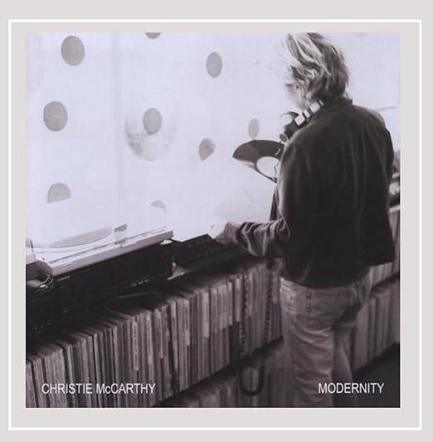

**Story Adaptation**

By: Mark Groo

I was immediately inspired to write this story after hearing this album for the first time, in Aug 2018.

I originally wanted to make a video of the story, but that project was too ambitious, so it sat for 5 years. This current version of the story was completed in May 2024.

**Dedication**

To Julie for her unconditional love.

To Christie for her musical and lyrical talents, and especially for her voice. Christie’s voice expresses the emotion of the music, perfectly. Her voice is silky smooth, over a wide range, and very easy to listen to.

This is a personal story with strong emotions, and for me, Christie’s low notes have the rawness and realness that convey that emotion. Very few vocalists affect me this way; Jack Bruce, David Bowie, Tom Petty are three, but the list is short.

I’m not comparing you to those artists, in the way you sound but rather in the way I am moved by their vocals. For me, the vocals need to be easy to listen to and convey a message that has value to me. Christie, you top my list of vocalists that move me emotionally.

**Introduction**

I am inspired by this album because each song represents a chapter of a story.

Each song builds on the prior, and they fit chronologically into a coherent story.

After listening to the album a few hundred times, many stories came to mind.

I have written 3 so far.

The story told here is about my relationship with Julie.

My original thought was to produce a video, with actors and shot on location, with the music supporting the story line. That became too ambitious for me, so the project was put on the shelf for a few years. Maybe someday that can be done, I haven’t given up on that idea.

I was inspired to finish this project due to a conversation I had with Julie, recently.

Revisiting the story and the music, I felt the emotion of the music the same as when I first heard it.

I suppose this music will always have that effect on me.

Thank you, Christie, and Julie.

**Credits**

All songs are written by Christie McCarthy, except.

* She’s Leaving Home: Paul McCartney, John Lennon

**Back Story**

This story begins in the summer of 2009.

But first, a brief personal history, leading up to 2009.

Julie and I grew up in the same neighborhood. We often met in the park while walking our dogs. And we attended the same high school. We never officially “dated” we were too shy for that.

Life was simpler then, we told stories, laughed, and enjoyed each other’s company. I heard Robin Trower for the first time while hanging out in her bedroom, probably without her mom knowing. Ha Ha



I graduated from Chico State University with a BSEE, in 1979.

Then enjoyed a long career in high tech as an Electrical Engineer.

Julie attended Humbolt State University and became a schoolteacher.

We lost touch with each other, during this time, for nearly 30 years.

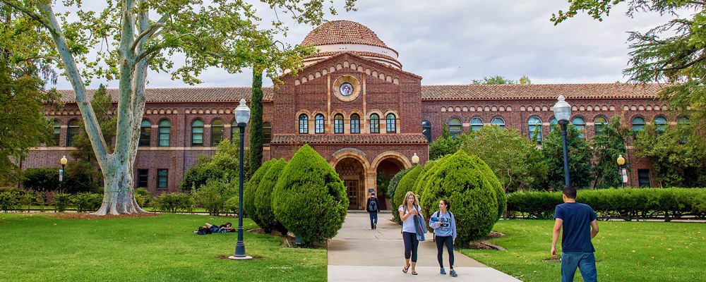 

At Seagate, I was a designer and problem-solver.

I prided myself on the ability to convert complex systems into smaller/simpler concepts, that could be understood by all.

I preferred to work alone and found it difficult to review my work with the team until I had my design complete and fully tested. This characteristic will repeat often in my life.

The high-tech career provided a steady income and lots of free time, away from work.

I had many other activities outside of work, both individually and with the family.

The mind-body connection was strong and healthy. We were living a good middle-class life, with all the toys and a picket fence to prove it.

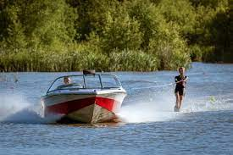 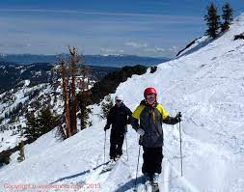

Life worked if I maintained the routine, working 9-5 and spending time with family, evenings, and weekends. But something was missing. A purpose.

I had a sense that there was more to life. I had more to offer and wanted more in return.

What that was exactly, I did not know.

 

In 2003 it came to a head.

Work had become very routine, political, and frustrating, and my marriage was failing too.

When the layoff was announced, I cheered. I was ready for a break.

I sold the house, bought a travel trailer, and took a 2-year sabbatical.

All the while, searching for my purpose and pursuit of happiness. Most of my adventures were exploring Southern Utah, Northern Arizona, and the High Sierras. Hiking, bicycling, and motorcycling. I spent most of that time alone and often alone in the wilderness.

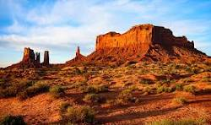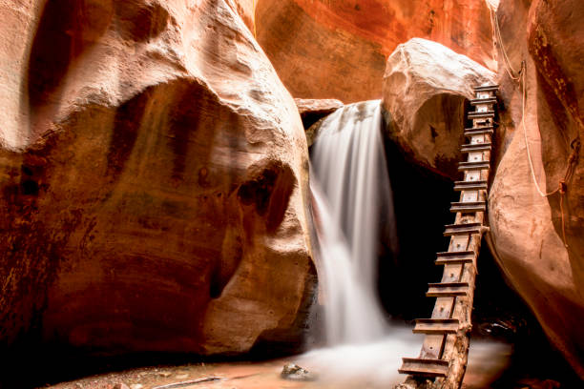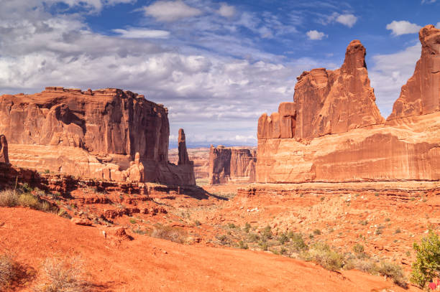

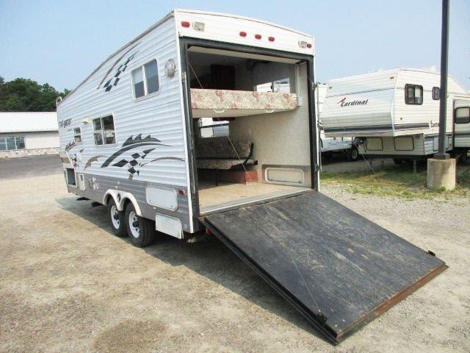

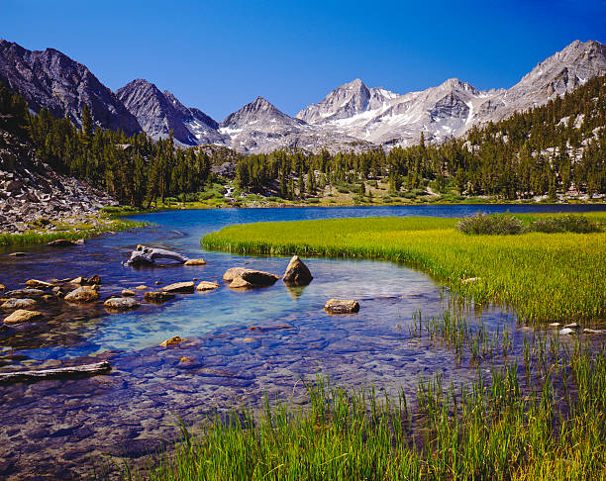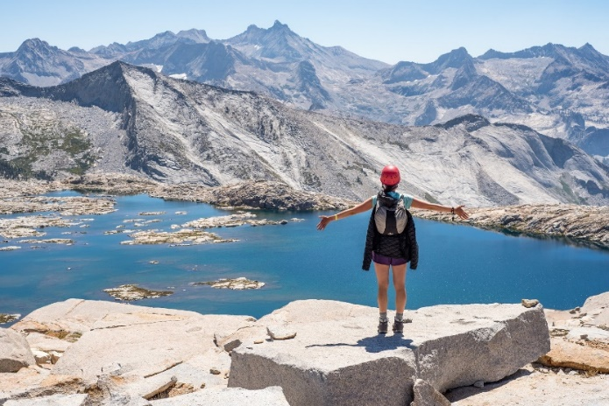

In the fall of 2004, I had a “light bulb” moment, while backpacking in the Sierras. Realizing that my passion was to promote health and well-being and starting a water store business could be the vehicle to do that.

At that time, I had never owned a business and had never worked in retail. It was all new to me. But I wasn’t going to let that deter me.

I had passion, confidence, and entrepreneurial spirit.

In 2005 I opened my business “Pure Water of Watsonville”.

With the goal of promoting health and well-being!

4 years later, 2009, I had no savings, $50k in debt, and working long hours.

Apparently, promoting health and well-being was not in demand.

My money ran out, my passion faded, and I was fighting depression.

What to do?

This is where this story begins.

**Note:**

Each song covers one chapter of this story.

The lyrics are indented and bolded.

Enjoy

**Fold**

This story begins in the summer of 2009.

 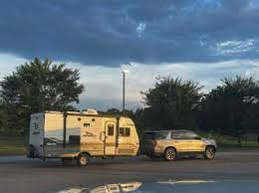

Often sleeping at the store or sleeping in my trailer parked in a driveway or on the street.

Searching for a way out of the mess I created.

Struggling to keep the business going.

Never imagined I would end up here, the path I found myself on.

I’m in a hole.



I pressed on, hiding my emotions from the public. Becoming withdrawn inside.

Outwardly kept a pretense of happiness and success.

Mornings were spent doing service work at customers’ homes.

The day was spent working on the retail side of the business, 12-7, 7 days a week.

Occasionally hiring help for a break.

Evenings were spent reconciling the transactions of the day and cleaning the store.

I spent many hours on my knees. Or taking walks along the coast at 3am.

**These are the years I was warned about**

**These are the days of dominos and searching souls**

**This is the path I am on right now**

**And I’m in a hole. I’m in a hole.**

I joined Facebook to follow a friend while he and his wife traveled. Two weeks after joining Facebook, I got a message that read; “Remember Me?” It was from Julie, my childhood friend!

We both needed emotional support. Me being depressed and her ending a marriage.

We rarely saw each other in person because we lived about 200 miles apart.

We felt very connected due to our childhood memories and common interests.

We shared everything and laughed about silly stuff, like we were kids again.



Within days we were falling in love.

Those were the days of the flip phone, we wore out the buttons on our phones, texting.

We filled an emotional hole in each of us.

Julie offered unconditional love.

She accepted me both in my present state and my past.

I felt safe with her.

**These are the tears I’ve been holding back**

**The fears that grip me like a glove**

**And you’re my better half**

**These are the times that I need your love**

**Baby please, hold your head up**

**When I have fallen to my knees**

**Baby please, hold your heart out**

**And be strong when I am weak**

**And if I fold, don’t let me go.**

**Funny how the time winds blow**

**To think when I was younger**

**All I wanted was to be old**

**And now all I want is to pull it together**

**Baby please**

**Hold your head up when I’ve fallen to my knees**

**Baby please**

**Hold your heart out and be strong when I’m weak**

**And if I fold**

**Don’t let me go, Don’t let me go**

**And if I never make the grade**

**Will you love me just the same**

**Will you feel the spark**

**Trust me with all your hear**

**I was just thinking about when I started**

**And every twist and turn of the road**

**It may take a minor miracle**

**But one thing I know, everyone grows**

**So, baby please**

**Hold your head up when I buckle at the knees**

**And if I’m cold**

**Don’t let me go, Don’t let me go**

**Baby please**

**Hold your head up when I’ve fallen to my knees**

**Baby please**

**Hold your heart out and be strong when I’m weak**

**And if I fold Don’t let me go, Don’t let me go**

**Modernity**

Julie needed time to resolve her marriage.

That gave me time to reflect on my life and find balance.

I told myself that I needed the time to find balance before being emotionally available.

If I were being honest with myself, I knew this was not about time, but rather pride and self-esteem. Given the state of mind I was in, struggling to keep the business going and making enough money to survive. I did not feel worthy to be in a relationship.

But the time afforded me the space to avoid that issue and enjoy the love she was offering.

I chose, instead, to be modest, sought no praise and didn’t fuss about it.

The western mind builds large fences of pride and ego often limiting our ability to stand tall. Julie sees deep in my eyes, a soul that is alive.

**The I Ching says be modest**

**Like a river flows and seeks no praise at all**

**The I Ching says don′t fuss about it**

**Let the stormy clouds pass through you now**

**Deep in your eyes I see the memory of a soul alive**

**Somewhere in time before modernity**

**And the Western mind**

**I have a hard time believing**

**In things I cannot see or offer proof to me**

**All of my time receding**

**Whatever Power be with me now**

**Deep in your eyes I see the memory of a soul alive**

**Somewhere in time before modernity**

**And the Western mind**

**And the Western mind**

**So many sleek advances**

**We're living large behind our fences**

**The I Ching says free yourself**

**You′re taller when you learn to bow**

**Deep in your eyes I see the memory of a soul alive**

**Somewhere in time before modernity**

**And the Western mind**

**And the Western mind**

**And the Western mind**

**Eucalyptus Tree**

I imagined being with Julie and what that would be like.

This chapter is a fantasy, all in my head.

   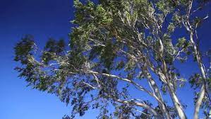

**I bet she makes love with abandon**

**Like a eucalyptus tree**

**Blowing in the Santa Ana wind**

**Her own skin softer than a breeze**

**When she′s wrapped in robe I follow**

**And imagine seeping tea**

**Desert red sand glow, camping in the snow**

**Rivers to the sea**

**And I sing hallelujah**

**Heaven shines its light on few**

**Hallelujah**

**In a basket meant for flowers**

**Or woolen ecru yarn**

**She carries poems in words that are her own**

**Loosely on her arm**

**Like a gift for everyone**

**And I sing hallelujah**

**Heaven shines its light on few**

**Hallelujah**

**When she's down I wanna be around**

**When she′s down I wanna be there**

**When she comes around**

**I bet she makes love with abandon**

**Like a eucalyptus tree**

**Rain**

Longing to be with Julie, yet so far away, so far apart.

I think it’s time, I need you home.

**I feel uptight**

**I′ve been holed up here for nights**

**What I wouldn't do for the sight of you**

**I′ve been alone**

**Just my vices on the phone**

**And I think it's time that I need you home**

The feeling of longing leaves me feeling empty like you went away.

I am black and blue, longing for you

**Raining down on me the foggy days**

**Raining down on me since you went away**

**Rain, rain, rain, rain**

**Love is like**

**A superhero by your side**

**When you need it most it's there for the taking**

**But if I thought**

**I could make you run so hard**

**So far from me, I wouldn′t have believed**

**Raining down on me the foggy days**

**Raining down on me since you went away**

**Rain, rain, rain, rain**

**I had a vision for us and it wasn′t this**

**I thought that when you give love**

**It's love you get**

**I was as green as the grass**

**But now I′m black and blue**

**Raining down on me the foggy days**

**Raining down on me since you went away**

**Rain, rain, rain, rain**

**Thank You Song**

Etheric voice speaking. A voice I hear in my head.

Grateful to be living and experiencing life.

Praising the Almighty One

While I was feeling grateful and praising God, I was not giving as much attention to Julie.

That was another form of avoidance. Not reciprocating the love Julie was giving.

As time passes by

**Just a quick thank you song to the Almighty One**

**I couldn′t write it down without my fingers and my thumb**

**Where do they come from, where do they come from**

**Where do they come from**

**Just a quick thank you song to my Ma and Pa**

**I couldn't write it down without the mystery of love**

**Where does that come from, where does that come from**

**Where does that come from**

**Just a quick thank you song to our Mother Earth**

**I couldn′t write it down without the ground to make my paper**

**Where does that come from, where does that come from**

**Where does that come from**

**Diving**

Two Lanes:

1. Walk away from the water store to be with Julie and face the shame of being broke and a failure in business. OR
2. Make something of the water store, which will take time away from Julie, to walk away with pride, knowing I was successful at the business?

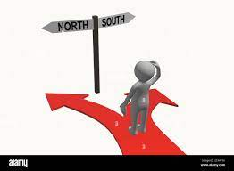 

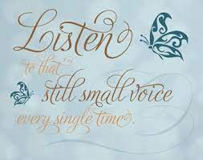 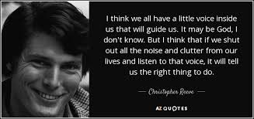

**Two lanes outside my door**

**One way south the other north**

**Two lanes which way to drive**

**And I′m listening hard for that little voice inside**

**Two lanes outside my door**

**One way peace the other war**

**Two ways to live and I**

**Am listening hard for that little voice inside**

**That little voice inside**

**Deep beneath the surface of our pride**

**Deeper than the whispering dares**

**Deeper still than the stuttering fears**

**Past the voices you wanna hear**

**Keep diving**

**Two lanes outside my door, Mr. President**

**God gave us many, many, many more**

**Than two ways to solve our strife**

**Are you listening**

**That little voice inside**

**Deep beneath the surface of your pride**

**Deeper than the words of your father**

**Deeper still than your profits and losses**

**Past the fields of burning crosses**

**Keep diving**

**That little voice inside**

**Deep beneath the surface of our pride**

**Deeper than the whispering dares**

**Deeper still than the stuttering fears**

**Past the voices you wanna hear**

**Keep diving**

The little voice inside was silenced by fear. The fear guided me to press on with my work.

Busy building fences. Not trusting the little voice inside.

The wisdom in this song says:

“keep diving”, “deep beneath the surface of our pride”.

“God gave us many, many, many more than two ways to solve our strife”

“Are you listening”

**Rainy Season**

Another season had passed, or had it been another year?

Procrastination and loss of time.

**It′s the rainy season**

**And what can I say**

**My bones are creaking**

**I've been inside all day**

**And lately, lazy mind lazy ass**

**Sprawled out like a cat**

**Dog-eared as my dharma paperbacks**

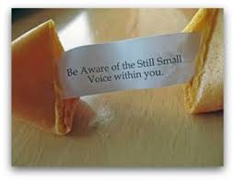

Be aware of the Still Small Voice within you.

Speak your truth, stop procrastinating, it will come out anyway, someday, like molten lava.

**I was born with my tongue**

**Down on the cutting floor**

**They wanted a daughter**

**Who′d think about what she would say before**

**The truth comes pouring out**

**Like molten lava**

**When it gets too hot inside bar the door**

Act on what is right, stop building the wall

**I'd like to build a wall so I could tear it down**

**I think about the first thing**

**I will teach my son or daughter**

**If you don't have anything that′s nice to say**

**Go ahead and say it your own way**

 

Losing sleep at night, if I could just sing her another song, a song called Angel

Procrastination and many sleepless nights.

Living in my head, not listening to the little voice inside.

**Now, my soul is the eternal**

**Starburst sky**

**But my body feels restless**

**I never can fall asleep sleep at night until**

**I sing that little girl**

**A song called Angel**

**And listen to the stories that she tells**

Julie remained consistent, offering encouragement with unconditional Love

**She says come closer**

**I have something that**

**I′ve been wanting to tell you**

**It's a secret that I think′s been too well kept**

**Just look at my perfect face**

**And see God's art**

**You know you′re perfect just the way you are**

Julie saw the greatness in me

**I'd like to build a wall so I could tear it down**

**I think about the first thing**

**I will teach my son or daughter**

**All the universe lives inside a pearl in a shell**

**And honey don′t you ever hide yourself**

Julie would often say her “love bucket” was empty.

I chose not to hear her. I chose not to say, “I love you”.

My fear not only silenced the little voice inside, but it also kept me unaware of her needs.

Another rainy season and the ache in her bones was getting heavy

**It's the rainy season**

**Down in my bones**

**But the pain's retreating**

**After such a huge and heavy load**

**Release it if you can**

**Your love will grow**

**I was a rain cloud I should know**

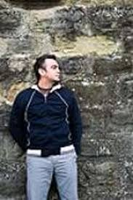  

I began to see the walls I built.

I began to wonder what I was hiding from.

Still procrastinating and holding on

**I′d like to build a wall so I could tear it down**

**I think about the first thing**

**I will teach my son or daughter**

**Took an old bag of songs**

**Turned ′em into flesh and bone**

**What you dream is what you own**

**You're so right you can′t go wrong**

**River Stone**

Julie’s love and support was getting through to me.

I felt love for her and felt inspired by her love.

The yoke of fear was breaking.

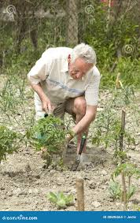 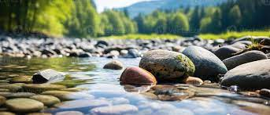 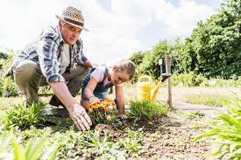 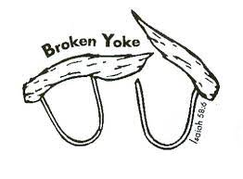

**Old man leans over his garden**

**Administers love from his finger tips**

**Gone is the thunder of 40 years younger**

**Gone the man who beat his kids**

**The hand of the devil has lost its grip**

**Hearts get open on their own**

**Ain′t that the way it goes**

**Time can turn a bed of thorns**

**Smooth as a river stone**

**Make it smooth as a river stone**

Family wounds cut deep, time heals, and the devil loses his grip

Another year passes by

**She's an ocean full of devotion**

**Her granddaughter thinks she′s the best thing around**

**When granddaughter's father looks at his mother**

**He sees the woman who cut him down**

**And he can't reconcile this turnabout**

**Hearts get open on their own**

**Ain′t that the way it goes**

**Time can turn a bed of thorns**

**Smooth as a river stone**

**Make it smooth as a river...**

**You never know what′s round the bend**

**You hope it's better than where you′ve been**

**Life will lead you where you have a seam to mend**

Healing the past and feeling stronger

**He was a real smooth operator**

**Won't let anybody get too close**

**Following in the ways of his father**

**Until the day he was diagnosed**

**The ironic relief of a broken yoke**

I think it’s time!

**Hearts get open on their own**

**Any way they know**

**Time can turn a life of thorns**

**Smooth as a river stone**

**Make it smooth as a river**

**Oh smooth as a river stone**

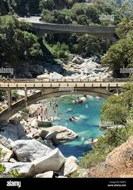

**Life**

I want to move into action, excited to spend more time with Julie.

I can imagine how that will feel.

But first, let’s get it right in my mind, how it will look and feel.

    

**I′m in the mood for a holiday**

**Just me and you and we'll fly away**

**People will guess when we′re not around**

**All over the office rumors will abound**

**Life is funny and it's free**

**I want you to walk this world with me**

**You look so serene tonight**

**And every road leads to paradise**

**We're on the runway this stretch aglow**

**You caught me thinking ′bout so long ago**

**It′s in my head like a record**

**I wanted to play it makes me feel so good**

**Life is funny and it's free**

**I want you to walk this world with me**

**You look so serene tonight**

**And every road leads to paradise**

**Life is funny and it′s free**

**I want you to walk this world with me**

**You look so serene tonight**

**And every road leads to paradise**

**Every road says welcome to paradise**

**Every road leads to paradise**

**The Thread**

I have done what I can with the water store. It is time to sell and move on.

Reminiscing about the memories of Julie and what is yet to be.

Much to do. Staying focused with the tasks at hand. Hold onto the thread that connects us.

Soon Julie and I will be together.

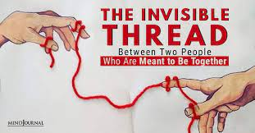 

**There′s a thread**

**That you follow**

**It goes among things**

**Things that change**

**But it doesn't change**

**People wonder about**

**What you are pursuing**

**What mystery abrew**

**Can make you**

**Hold yourself right**

**Hold onto that thread**

**With every fiber inside**

**Let go what′s dragging behind**

**Hold onto that thread**

**It'll pull you through hard, hard times**

**While you hold it**

**Baby you can't get lost**

**Should tragedy befall**

**When you hurt, when you get old**

**And nothing you do**

**Can stop time unfolding**

**Though that′s the way it is**

**You don′t let go of the thread, you**

**Hold yourself right**

**Hold onto that thread**

**With every fiber inside**

**Let go what's dragging behind**

**Hold onto that thread**

**It′ll pull you through hard, hard times**

**Think you got your feet on the ground**

**Then the wild wind comes around**

**Picks you right up like the tide**

**And you say thank you**

**Thank you for the ride**

**Hold yourself right**

**Hold onto that thread**

**With every fiber inside**

**Let go what's dragging behind**

**Hold onto that thread**

**It′ll pull you through hard**

**Hold onto that thread**

**It'll pull you though hard**

**Hold onto that thread**

**It′ll pull you through hard, hard times**

**She's Leaving Home by The Beatles**

I arrived at Julie’s doorstep, but something was wrong. She was not home.

How could this be? Everything was working out as planned…Where is she?

Then it hit me,

* Whose plan was I following? Not her plan.
* How much time has passed! Months turned into years.

The warning signs were there. The errors of my ways swarmed in my head.

* I chose not to pay attention.
* My pride and fear held me back.
* I built a wall, to be safe and only focus on my side.

In my defense, I wanted to get it right. It worked in the past. Why not now?

This was a shock to my system.

I began to question reality.

My basis for knowing what I knew, was in doubt.

Like waking up from a dream, and realizing it isn’t a dream, this is my reality now.

Life passed me by.

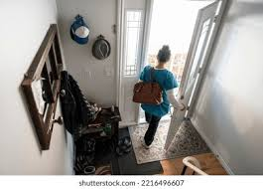 

**Wednesday morning at five o'clock**

**As the day begins**

**Silently closing her bedroom door**

**Leaving the note that she hoped would say more**

**She goes down the stairs to the kitchen**

**Clutching her handkerchief**

**Quietly turning the backdoor key**

**Stepping outside, she is free**

**She,... (we gave her most of our lives)**

**Is leaving (sacrified most of our lives)**

**Home (we gave her everything money could buy)**

**Father snores as his wife gets into her dressing gown**

**Picks up the letter that's lying there**

**Standing alone at the top of the stairs**

**She breaks down and cries to her husband**

**Daddy, our baby's gone.**

**Why would she treat us so thoughtlessly?**

**How could she do this to me?**

**She (we never thought of ourselves)**

**Is leaving (never a thought for ourselves)**

**Home (we struggled hard all our lives to get by)**

**She's leaving home, after living alone, for so many years**

**Friday morning, at nine o'clock**

**She is far away**

**Waiting to keep the appointment she made**

**Greeting a man from the Motortrade**

**She (what did we do that was wrong)**

**Is Having (we didn't know it was wrong)**

**Fun (fun is the one thing that money can't buy)**

**Something inside, that was always denied,**

**For so many years,.**

**She's leaving home**

 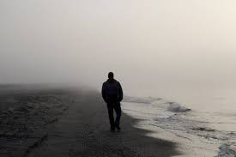

**Conclusion**

There are a few things I can gleam from this story:

* Time does not wait for us to get it right.
* Sometimes decisions are required when we are not ready. Listen to the little voice inside.
* Love can sweep us off our feet, when we least expect it, and pass just as quickly.
* Make choices (act) based on the goals we have set for ourselves.
* Life is a journey, and we are here to experience life as fully as we can, or not. It is our choice.
* Identify decisions based on bad values such as fear, shame, pride, hopefully before acting on them. I suppose this will be a process of constant awareness and improvement.
* God gave us many more than two ways to solve our strife.

What I am grateful for and where I plan to go from here:

* I am extremely humbled by this experience.
* I am grateful for the inspiration this music gave me to tell this story.
* I am extremely grateful for the love Julie gave, unconditionally.
* I will commit myself to speak my truth, listen to the little voice inside and not hide from fear.
* My current passion is Soil Biology. We can heal the planet and restore abundance by getting the Soil Biology healthy and balanced in our Soils. I am working toward a certificate from a reputable school which will allow me to consult and live a gypsy lifestyle of traveling to where I am needed to help restore land and help farmers.
* The water store is in escrow to be sold. Once it is sold, I will be free to explore and study again.

Regarding Julie, I have beat myself up pretty good for many years, since she left. Hopefully telling this story gives me closure. I know we will be connected always, but for now we have separate lives to live.

My intuition tells me that when we are both old, we will be together again. I see us sitting on a porch together, rocking, laughing, and telling stories. And if we are still able to hike, maybe a few hikes too. Love you, Julie. I wonder if our initials are still carved into that tree from when we were just teenagers.

Julie is the one standing, behind me, in the picture below.

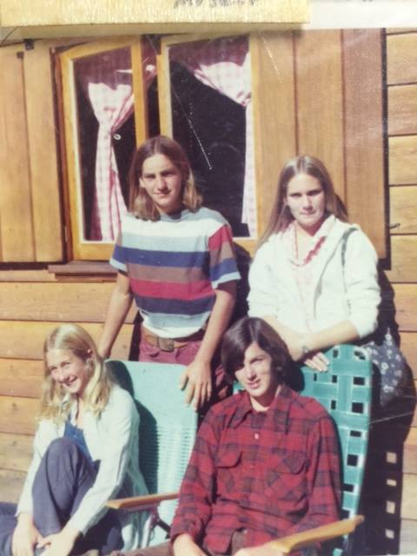

Thank you, Christie.

What a wonderful gift this has been for me.